**How to activate a Long-Click**

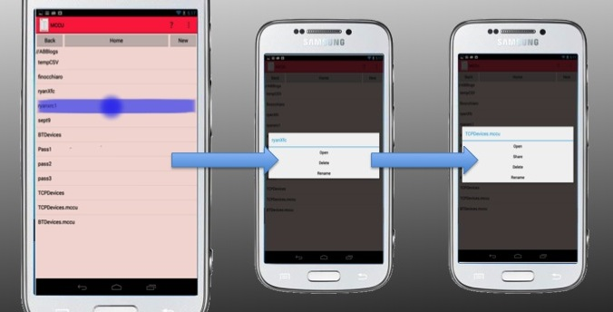

To bring up options for files, folders, or connected devices in MCCU, hold your finger on the clickable item. After your finger is held on the item, a pop-up dialogue will prompt you of your Long-Click options.